Data Structures Mini Project

Subject & Code:- UCS1312 Data Structures Lab

MOVIE TICKET RESERVATION

***Abstract:-***

The main aim is to use linked list to book, cancel and check the availability of tickets for the movie in a theatre. To book the tickets based on the available dates, name of the viewer and seat number.

Also to implement the payment method by credit or debit card or by net banking and UPI. To generate the payment bill along with taxes and display the bill.

And also to cancel tickets based on seat number and name of the viewer. After cancelling the time for the refunding process is processed and displayed.

The viewer name and their respective seat number booked are stored in a separate text file for both today and tomorrow to view the availability.

***Methodology:-***

The program contains function to

1.Book tickets for the movie.

*Payment with

Credit card

Debit card

Internet banking

2.Cancel the booked tickets.

3.To check the available seats in theatre.

“mini.c”

It contains the main driver program.

**node*insert(int c)**

This function is used to create node and store the seat number in a text file.

**node* book_1(node* a,char b[][10],char c[],int d)**

This function is used to book the the tickets according to the seat number and name of the person for todays movie.

**node* cancel_1(node *a,char b[][20],int c)**

This function is used to cancel the booked tickets with customer name and the seat number of the tickets to be canceled.

**void update(node *a,char c[20])**

This function is used to update the name of the customer who booked the tickets in the text file.

**void checkavailabilty(char a[][30],char b[][30])**

This function is used to display the available seats with their sat

numbers.

**void bookseats(char a[][30],char b[],int c)**

This function is used to book seats for the movie with input of customer name and seat number.

**int cancel(char a[],int b)**

This function is used to cancel the tickets with customer name and seat number.

**void payment(int a)**

This function is used to display the options of your payment mode and display the payroll for every individual mode of payment.

***Output Screenshots and description:-***

1. 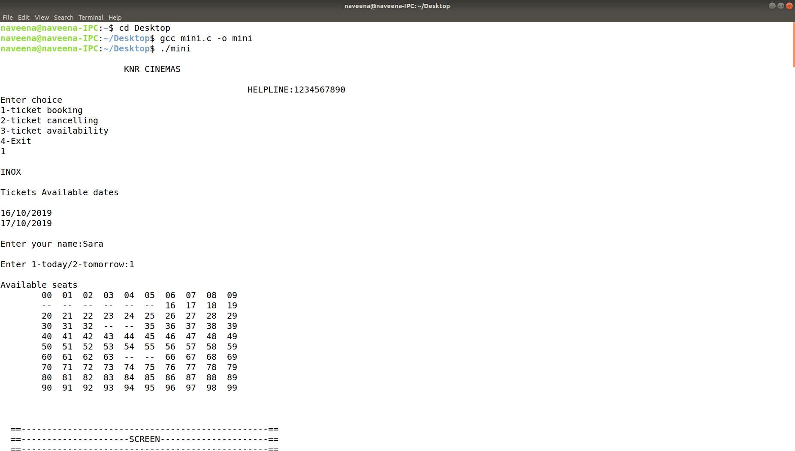the screenshots of booking and payment for the ticket

The above screenshots are generated using a linked list. It provides the necessary choices such as ticket booking, ticket cancelling and ticket availability. The last option is to exit. Also displays the helpline number along with the theatre’s name.

On selecting the first option the screen name in which the movie is screening along with the available dates and gets the input of the viewer’s name. If the option today or tomorrow is selected it displays the available seats

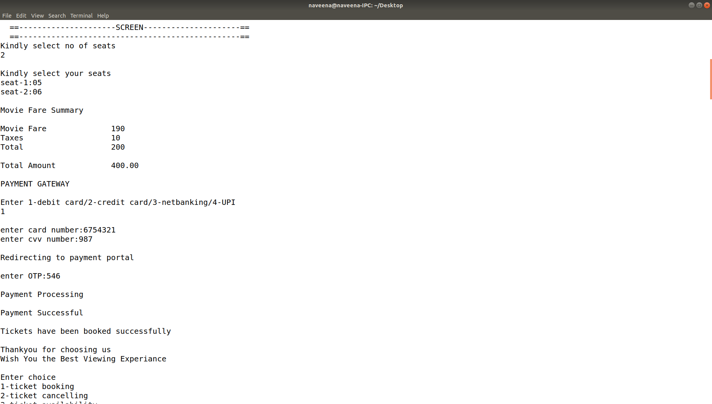

The available seats in the screen are displayed, it allows the viewer to select the number of seats required and the seat number.

After selecting the seats, the movie fare is displayed along with the taxes and also enables the user to pay using various payment options such as debit or credit card, net banking and UPI.

For the payment it asks for the card number, ccv number and an OTP is generated. After all this process the payment is done successfully and it is displayed with a Thank You message and wishing the viewer to enjoy their experience.

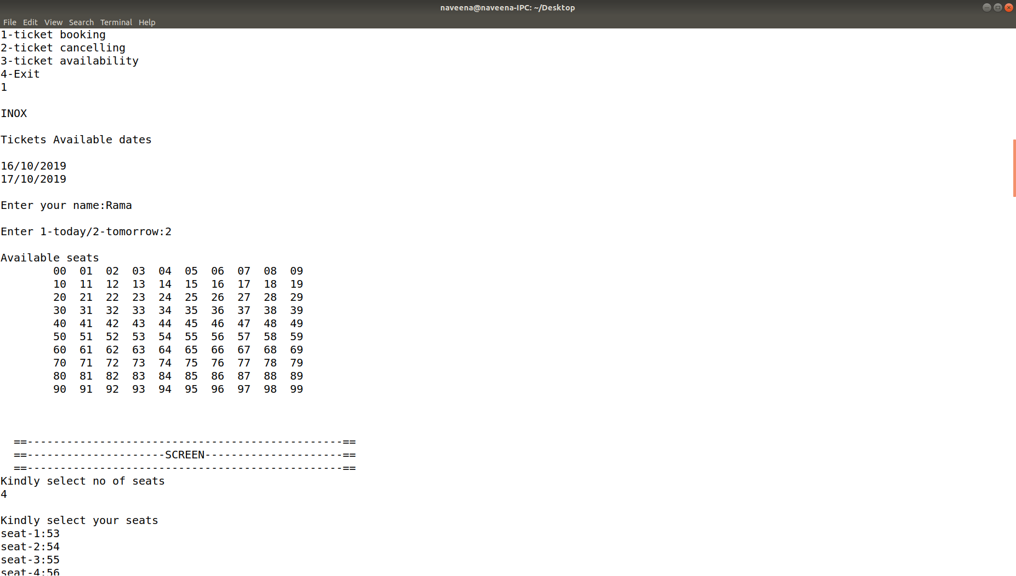

This screenshot is about the booking information of the other viewer which follows same process as for the first viewer, it displays the name of the screen along with the available dates and the viewer name.

It also displays the available seats to the viewer to check the number of seats, the seats booked are not displayed with number but displayed with double dash.

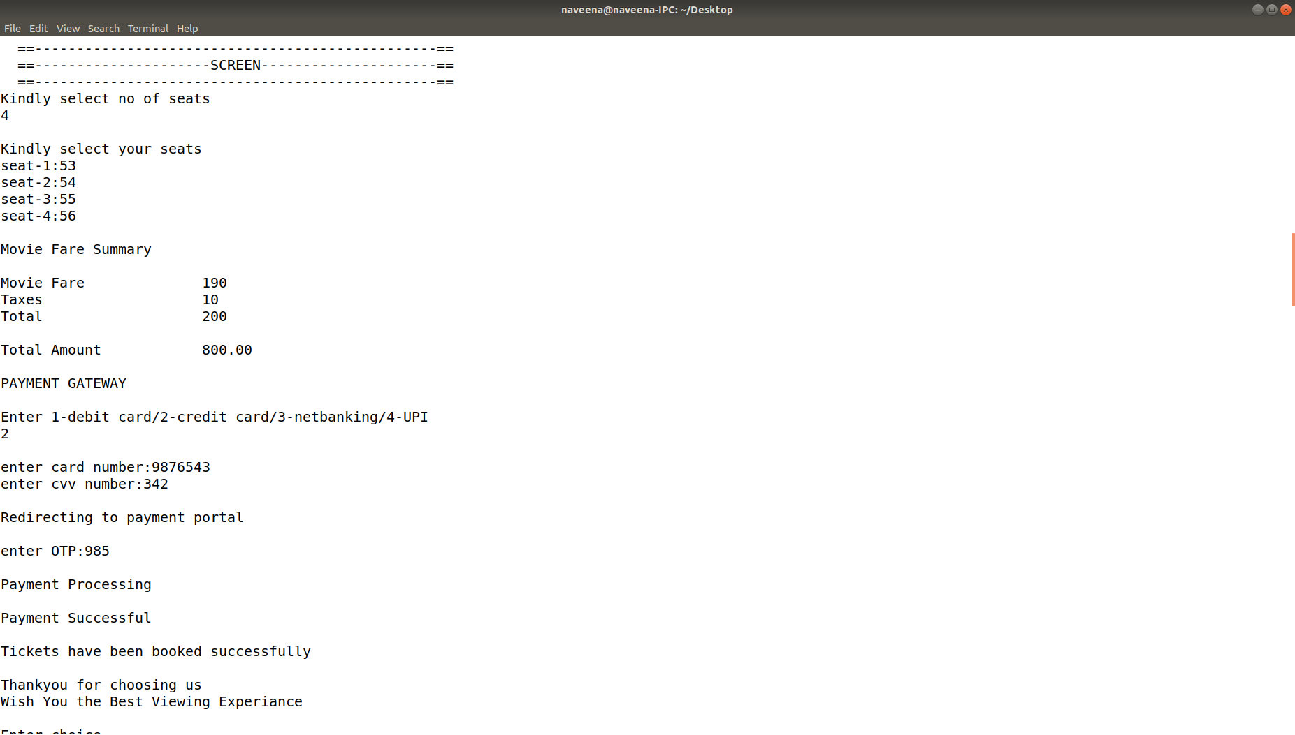

The available seats in the screen are displayed, it allows the viewer to select the number of seats required and the seat number.

After selecting the seats, the movie fare is displayed along with the taxes and also enables the user to pay using various payment options such as debit or credit card, net banking and UPI.

For the payment it asks for the card number, ccv number and an OTP is generated. After all this process the payment is done successfully and it is displayed with a Thank You message and wishing the viewer to enjoy their experience.

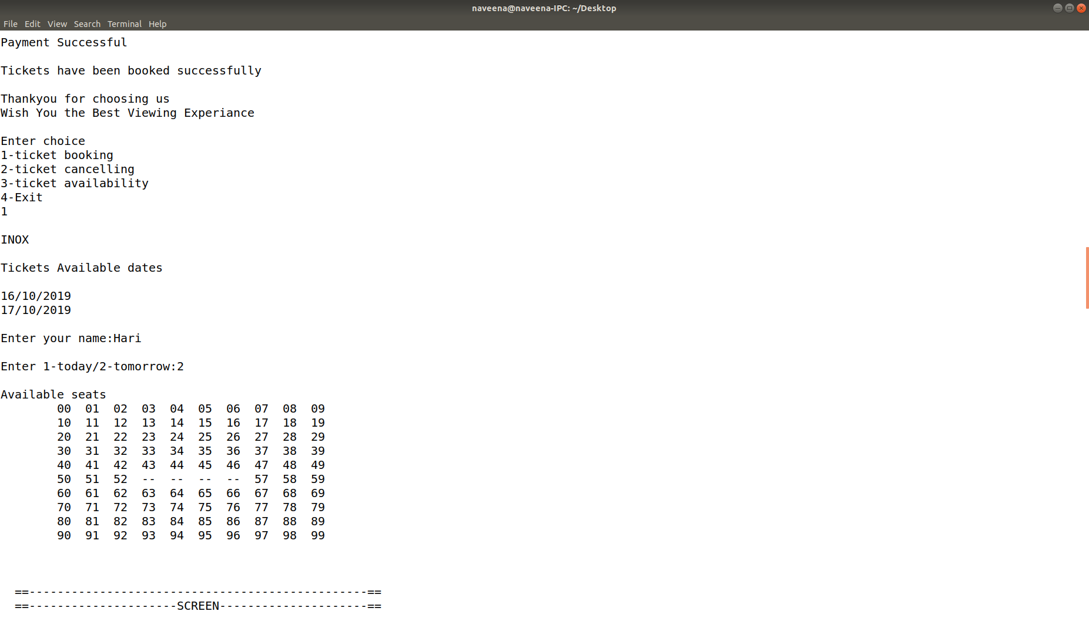

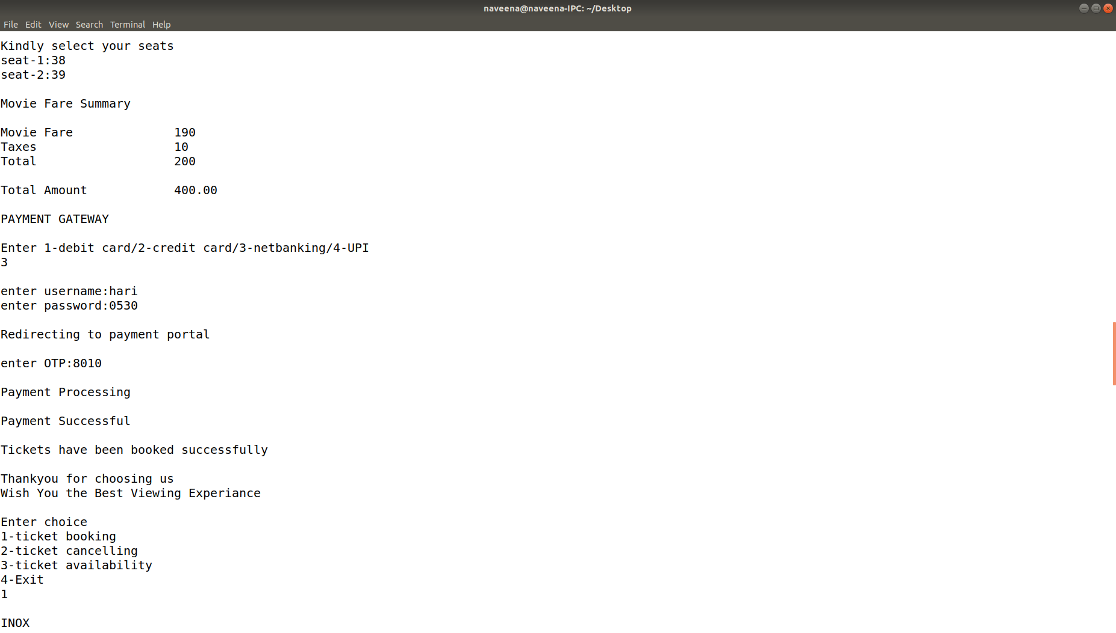

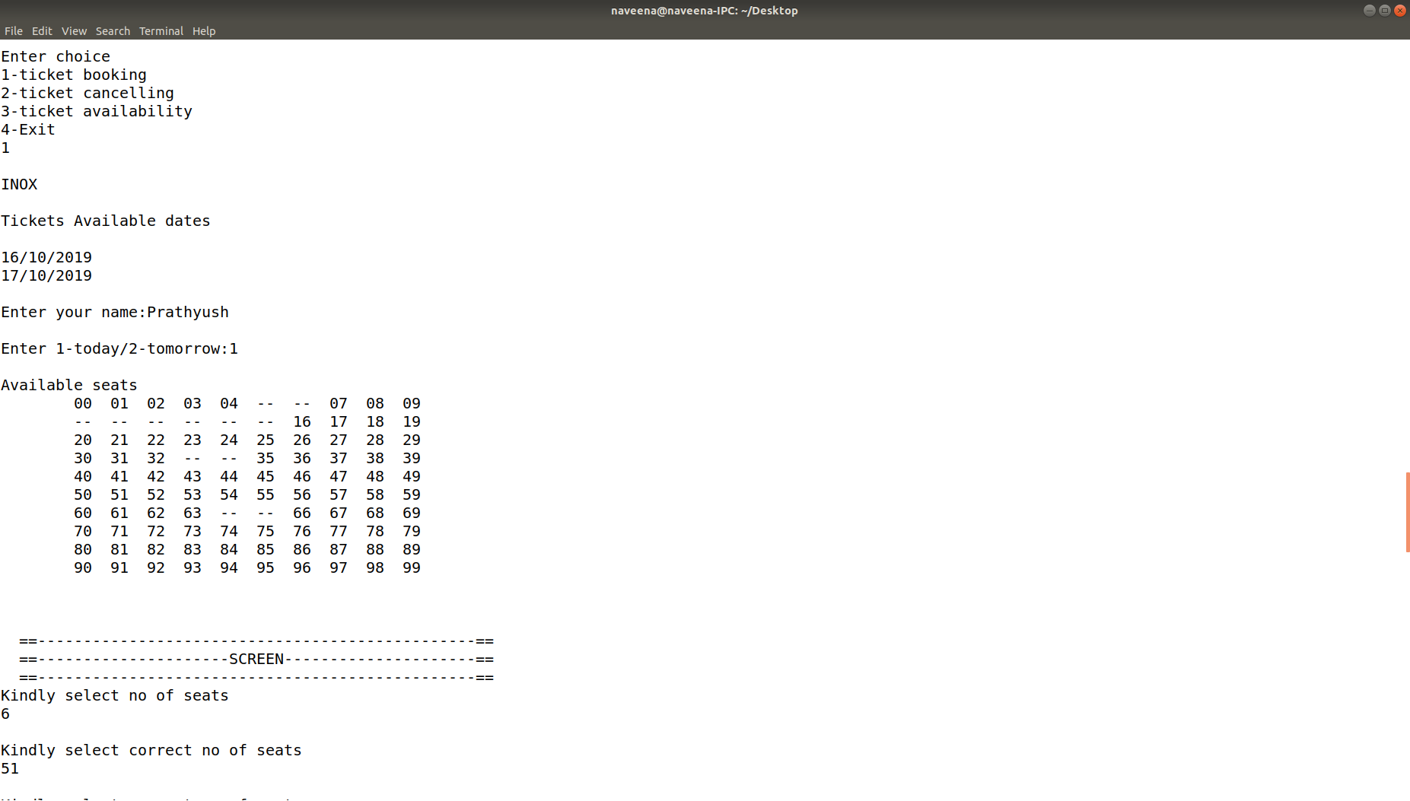

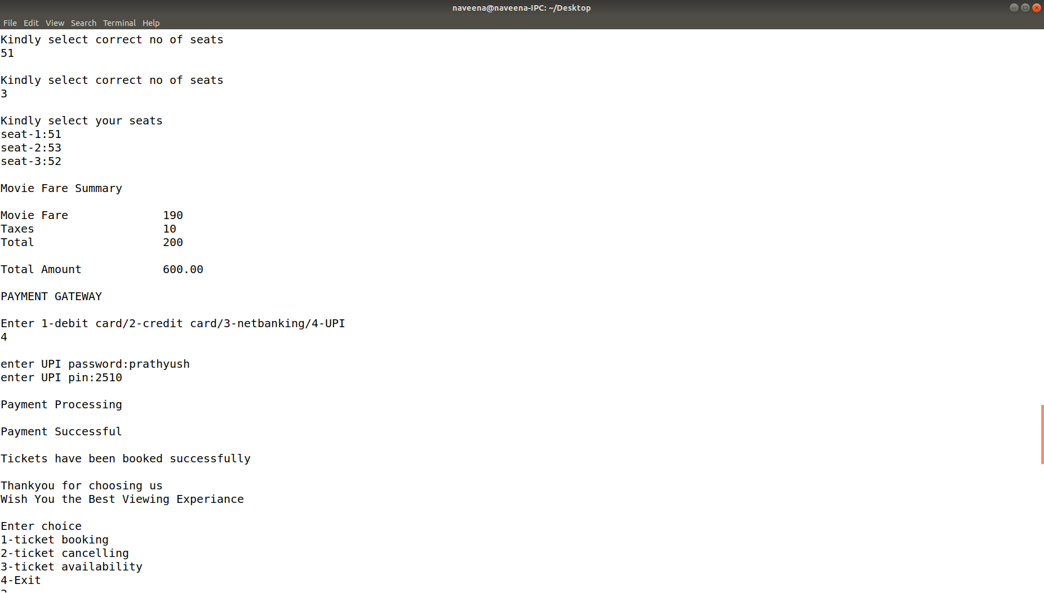

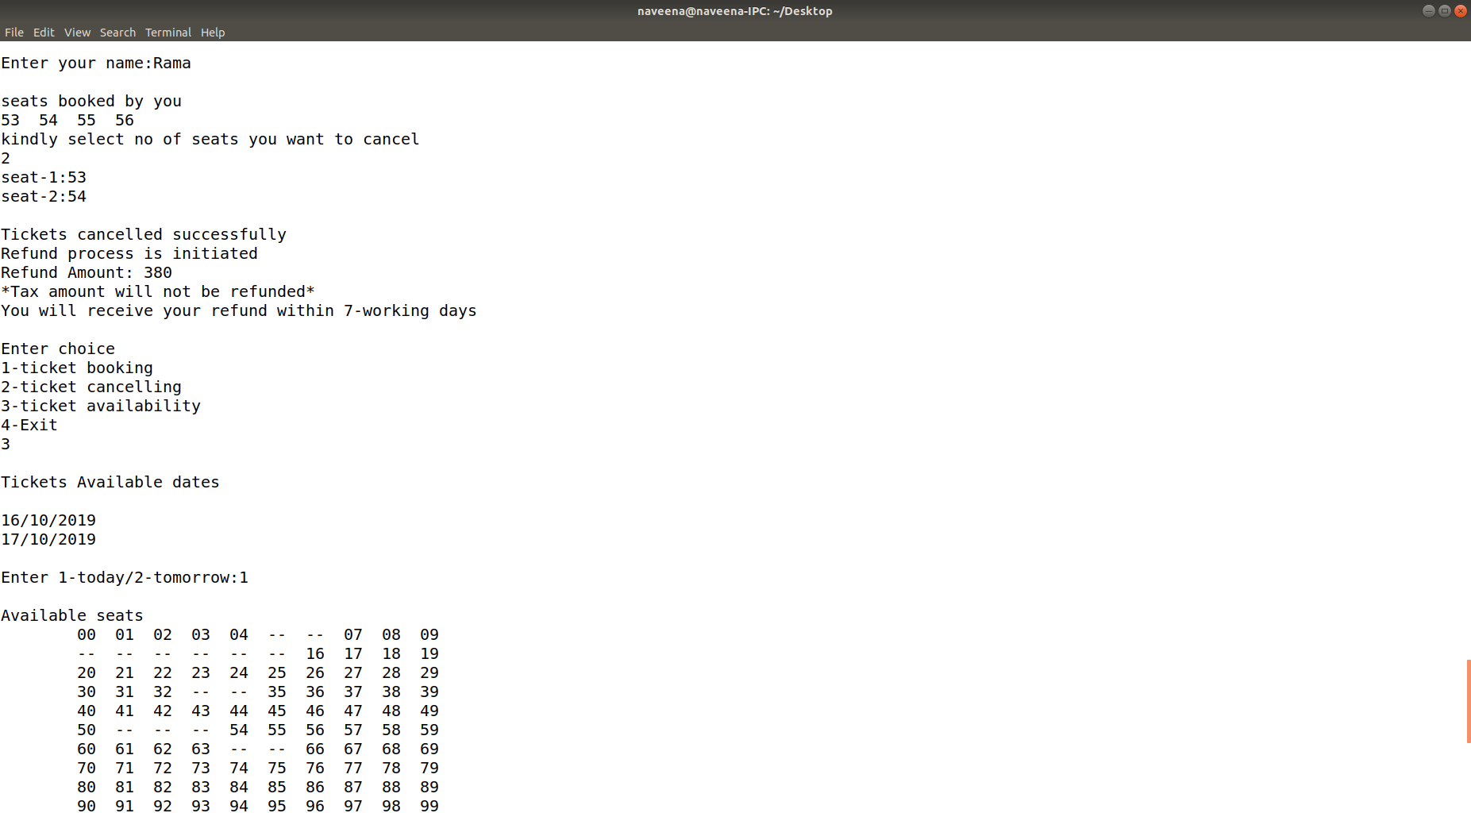2.After three viewers booked for the tickets and payment is done. The below screenshots are the cancelling process and availability of tickets:-

After the Booking process, the payment process is done successfully using various payment methods given above in the screenshot in the previous page.

It provides choices for the viewer to cancel if he/she is not willing to cancel then it goes to the next option that is the availability of seats and it displays the seats booked by all viewers.

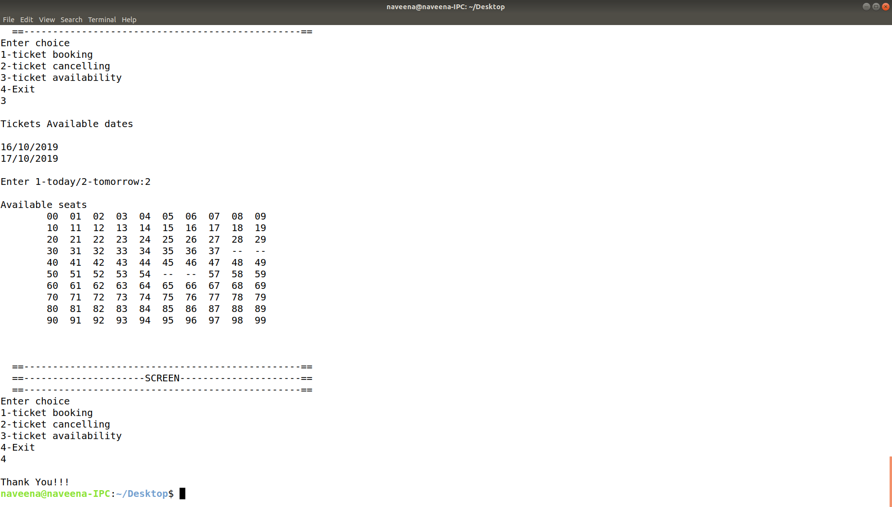

The Second option ticket Cancelling is selected, it asks for the date on which the ticket should be cancelled and the name of the viewer. After entering the name, it displays the tickets booked by the viewer and enables them to delete or cancel the ticket based on the seat number.

The cancelled message is displayed along with the refunding process. The Process displays the refunded amount and the day within which the amount would be refunded. And the final option is to exit.

***Code:-***

***File_op.h:-***

#include<stdio.h>

#include<stdlib.h>

#include<string.h>

typedef struct mynode

{

char seat[20];

struct mynode *next;

}node;

void payment(int a);

node* insert(int c)

{

FILE *fptr;

node *p,*head,*temp;

int i,j=0;

char ch[20];

if(c==1)

{

fptr=fopen("today.txt","r");

p=(node*)malloc(sizeof(node));

head=p;

for(i=0;i<100;i++)

{

fscanf(fptr,"%s",ch);

strcpy(p->seat,ch);

temp=(node*)malloc(sizeof(node));

p->next=temp;

p=p->next;

}

fclose(fptr);

}

else

{

fptr=fopen("tom.txt","r");

p=(node*)malloc(sizeof(node));

head=p;

for(i=0;i<100;i++)

{

fscanf(fptr,"%s",ch);

strcpy(p->seat,ch);

temp=(node*)malloc(sizeof(node));

p->next=temp;

p=p->next;

}

fclose(fptr);

}

return head;

}

node* book_1(node* a,char b[][10],char c[],int d)

{

int i;

node *temp;

FILE *fptr;

for(i=0;i<d;i++)

{

temp=a;

while(temp->next!=NULL)

{

if(temp->seat[0]==b[i][0]&&temp->seat[1]==b[i][1])

{

strcat(temp->seat,c);

break;

}

else temp=temp->next;

}

}

return a;

}

node* cancel_1(node *a,char b[][20],int c)

{

int i;

node *temp;

char ch[20];

for(i=0;i<c;i++)

{

temp=a;

while(temp->next!=NULL)

{

if(temp->seat[0]==b[i][0]&&temp->seat[1]==b[i][1])

{

ch[0]=temp->seat[0];

ch[1]=temp->seat[1];

strcpy(temp->seat,ch);

break;

}

else temp=temp->next;

}

}

return a;

}

void update(node *a,char c[20])

{

FILE *fptr;

node *temp;

temp=a;

fptr=fopen(c,"w");

while(temp->next!=NULL)

{

fprintf(fptr,"%s\n",temp->seat);

temp=temp->next;

}

fclose(fptr);

}

void checkavailabilty(char a[][30],char b[][30])

{

FILE *fptr;

fptr=fopen("today.txt","r");

char c[20];

int i,j=1,k=1,co=0,co1=0;

for(i=0;i<100;i++)

{

fscanf(fptr,"%s",c);

{

if(c[2]<65)

{

a[j][0]=c[0];

a[j][1]=c[1];

j++;

co++;

}

else

{

a[j][0]='-';

a[j][1]='-';

j++;

}

}

}

fclose(fptr);

fptr=fopen("tom.txt","r");

for(i=0;i<100;i++)

{

fscanf(fptr,"%s",c);

{

if(c[2]<65)

{

b[k][0]=c[0];

b[k][1]=c[1];

b[k][2]='\0';

k++;

co1++;

}

else

{

b[k][0]='-';

b[k][1]='-';

k++;

}

}

}

fclose(fptr);

if(co==0) a[0][0]='n';

else a[0][0]='y';

if(co1==0) b[0][0]='n';

else b[0][0]='y';

return;

}

void bookseats(char a[][30],char b[],int c)

{

node *p,*p1;

int j,l,i=0,n,len=0,d=1,ab1=0;

char li[20][10],c1[20],se[10];

printf("\nKindly select no of seats\n");

j=1;

while(ab1<100){

if(a[d][0]>=48&&a[d][0]<=58){

len++;

d++;}

ab1++;

}

do

{

scanf(" %d",&n);

if(n<len) j=0;

else printf("\nKindly select correct no of seats\n");

}while(j);

printf("\nKindly select your seats\n");

for(j=0;j<n;j++)

{

printf("seat-%d:",j+1);

scanf("%s",se);

for(l=1;l<=100;l++)

{

if(strcmp(a[l],se)==0) break;

}

if(l<=100)

{

strcpy(li[i],se);

i++;

}

else

{

printf("kindly select available seats\n");

j--;

}

}

p=insert(c);

p=book_1(p,li,b,i);

if(c==1) update(p,"today.txt");

else update(p,"tom.txt");

payment(n);

return;

}

int cancel(char a[],int b)

{

FILE *fptr;

int i,j=0,n,t=0,l,t1,c2=0;

char ch[20][20],c1[20][3],se[10],li[20][20],c[20];

node *p;

if(b==1) fptr=fopen("today.txt","r");

else fptr=fopen("tom.txt","r");

for(i=48;i<58;i++)

{

for(int x=48;x<58;x++)

{

ch[c2][0]=i;

ch[c2][1]=x;

for(t1=2;t1<20;t1++) ch[c2][t1]='\0';

fscanf(fptr,"%s",c);

strcat(ch[c2],a);

if((strcmp(c,ch[c2]))==0)

{

c1[j][0]=c[0];

c1[j][1]=c[1];

c1[j][2]='\0';

j++;

}

}

c2++;

}

fclose(fptr);

int len=0,d=0;

while(c1[d][0]>=48&&c1[d][0]<=58){

len++;

d++;

}

if(c1[0][0]=='\0') {

printf("\nYou don't have any booking on this date\n");

return 0;

}

else

{

printf("\nseats booked by you\n");

for(i=0;i<j;i++)

{

printf("%c%c ",c1[i][0],c1[i][1]);

}

printf("\nkindly select no of seats you want to cancel\n");

j=1;

do

{

scanf("%d",&n);

if(n<=len)

j=0;

else

printf("\nkindly select correct no of seats\n");

}while(j);

for(j=0;j<n;j++)

{

printf("seat-%d:",j+1);

scanf("\n%s",se);

for(l=0;l<len;l++)

{

if(strcmp(c1[l],se)==0)

break;

}

if(l<len)

{

strcpy(li[t],se);

t++;

}

else

{

printf("kindly select seats booked by you\n");

j--;

}

}

p=insert(b);

p=cancel_1(p,li,t);

if(b==1) update(p,"today.txt");

else update(p,"tom.txt");

}

return n;

}

void payment(int a)

{

int i,n;

char ca[20],cv[20],ot[20],ch[20];

printf("\nMovie Fare Summary\n\n");

printf("Movie Fare\t\t190\n");

printf("Taxes \t\t10\n");

printf("Total \t\t200\n");

printf("\nTotal Amount\t\t%d.00\n",(200*a));

printf("\nPAYMENT GATEWAY\n");

printf("\nEnter 1-debit card/2-credit card/3-netbanking/4-UPI\n");

scanf("%d",&i);

printf("\n");

if(i==1)

{

printf("enter card number:");

scanf("\n%s",ca);

printf("enter cvv number:");

scanf("\n%s",cv);

printf("\nRedirecting to payment portal\n");

printf("\nenter OTP:");

scanf("\n%s",ot);

printf("\nPayment Processing\n");

}

else if(i==2)

{

printf("enter card number:");

scanf("\n%s",ca);

printf("enter cvv number:");

scanf("\n%s",cv);

printf("\nRedirecting to payment portal\n");

printf("\nenter OTP:");

scanf("\n%s",ot);

printf("\nPayment Processing\n");

}

else if(i==3)

{

printf("enter username:");

scanf("\n%s",ca);

printf("enter password:");

scanf("\n%s",cv);

printf("\nRedirecting to payment portal\n");

printf("\nenter OTP:");

scanf("\n%s",ot);

printf("\nPayment Processing\n");

}

else

{

printf("enter UPI password:");

scanf("\n%s",ca);

printf("enter UPI pin:");

scanf("\n%s",cv);

printf("\nPayment Processing\n");

}

printf("\nPayment Successful\n");

printf("\nTickets have been booked successfully\n\n");

printf("Thankyou for choosing us\n");

printf("Wish You the Best Viewing Experiance\n");

return;

}

***Mini.c:-***

#include<stdio.h>

#include<time.h>

#include"file_op.h"

void main()

{

FILE *fptr;

int n,i=1,j=1,l,age,num,t=1,y;

char ch,gen,a[120][30],b[120][30],name[100],user[100],pass[100],se;

time_t T=time(NULL);

struct tm tm=*localtime(&T);

printf("\n\t\t\tKNR CINEMAS\n\n");

printf("\t\t\t\t\t\tHELPLINE:1234567890");

do{

printf("\nEnter choice \n1-ticket booking\n2-ticket cancelling\n3-ticket availability\n4-Exit\n");

scanf("%d",&l);

if(l==1)

{

printf("\nINOX\n");

checkavailabilty(a,b);

if(a[0][0]=='y'||b[0][0]=='y') printf("\nTickets Available dates\n\n");

if(a[0][0]=='y') printf("%d/%d/%d\n",tm.tm_mday,tm.tm_mon+1,tm.tm_year+1900);

if(b[0][0]=='y')

{

if(tm.tm_mon%2==0)

{

if(tm.tm_mday+1<32) printf("%d/%d/%d\n",tm.tm_mday+1,tm.tm_mon+1,tm.tm_year+1900);

else

{

i=tm.tm_mday%31;

printf("%d/%d/%d\n",i,tm.tm_mon+2,tm.tm_year+1900);

}

}

else

{

if(tm.tm_mday+1<31) printf("%d/%d/%d\n",tm.tm_mday+1,tm.tm_mon+1,tm.tm_year+1900);

else

{

i=tm.tm_mday%30;

printf("%d/%d/%d\n",i,tm.tm_mon+2,tm.tm_year+1900);

}

}

}

if(a[0][0]=='n'&&b[0][0]=='n')

{

printf("\nSorry no tickets are available\n");

break;

}

int count=0;

printf("\nEnter your name:");

scanf("\n%[^\n]",user);

do

{

if((a[0][0]=='y')&&(b[0][0]=='y'))

{

printf("\nEnter 1-today/2-tomorrow:");

scanf("%d",&n);

if(n==1)

{

count=0;

printf("\nAvailable seats\n\t");

for(l=1;l<=100;l++)

{

printf("%s ",a[l]);

if(++count==10)

{

printf("\n\t");

count=0;

}

}

printf("\n\n");

printf("\n ==------------------------------------------------==");

printf("\n ==---------------------SCREEN---------------------==");

printf("\n ==------------------------------------------------==");

bookseats(a,user,1);

j=0;

}

else if(n==2)

{

count=0;

printf("\nAvailable seats\n\t");

for(l=1;l<=100;l++)

{

printf("%s ",b[l]);

if(++count==10)

{

printf("\n\t");

count=0;

}

}

printf("\n\n");

printf("\n ==------------------------------------------------==");

printf("\n ==---------------------SCREEN---------------------==");

printf("\n ==------------------------------------------------==");

bookseats(b,user,2);

j=0;

}

}

else if(a[0][0]=='y')

{

count=0;

printf("\ntoday\n");

printf("\nAvailable seats\n\t");

for(l=1;l<=100;l++)

{

printf("%s ",a[l]);

if(++count==10)

{

printf("\n\t");

count=0;

}

}

printf("\n\n");

printf("\n ==------------------------------------------------==");

printf("\n ==---------------------SCREEN---------------------==");

printf("\n ==------------------------------------------------==");

bookseats(a,user,1);

j=0;

}

else if(b[0][0]=='y')

{

count=0;

printf("\ntomorrow\n");

printf("\nAvailable seats\n\t");

for(l=1;l<=100;l++)

{

printf("%s ",b[l]);

if(++count==10)

{

printf("\n\t");

count=0;

}

}

printf("\n\n");

printf("\n ==------------------------------------------------==");

printf("\n ==---------------------SCREEN---------------------==");

printf("\n ==------------------------------------------------==");

bookseats(b,user,2);

j=0;

}

else printf("\nkindly select today/tomorrow\n");

}while(j);

t=0;

}

else if(l==2)

{

printf("enter 1-today/2-tomorrow:");

scanf(" %d",&j);

printf("\nEnter your name:");

scanf("\n %[^\n]",user);

y=cancel(user,j);

if(y!=0){

printf("\nTickets cancelled successfully\n");

printf("Refund process is initiated\n");

printf("Refund Amount: %d\n",y*190);

printf("*Tax amount will not be refunded*\n");

printf("You will receive your refund within 7-working days\n");

}

t=0;

}

else if(l==3)

{

checkavailabilty(a,b);

if(a[0][0]=='y'||b[0][0]=='y') printf("\nTickets Available dates\n\n");

if(a[0][0]=='y') printf("%d/%d/%d\n",tm.tm_mday,tm.tm_mon+1,tm.tm_year+1900);

if(b[0][0]=='y')

{

if(tm.tm_mon%2==0)

{

if(tm.tm_mday+1<32) printf("%d/%d/%d\n",tm.tm_mday+1,tm.tm_mon+1,tm.tm_year+1900);

else

{

i=tm.tm_mday%31;

printf("%d/%d/%d\n",i,tm.tm_mon+2,tm.tm_year+1900);

}

}

else

{

if(tm.tm_mday+1<31) printf("%d/%d/%d\n",tm.tm_mday+1,tm.tm_mon+1,tm.tm_year+1900);

else

{

i=tm.tm_mday%30;

printf("%d/%d/%d\n",i,tm.tm_mon+2,tm.tm_year+1900);

}

}

}

if(a[0][0]=='n'&&b[0][0]=='n')

{

printf("\nSorry no tickets are available\n");

break;

}

int count=0;

do

{

if((a[0][0]=='y')&&(b[0][0]=='y'))

{

printf("\nEnter 1-today/2-tomorrow:");

scanf("%d",&n);

if(n==1)

{

count=0;

printf("\nAvailable seats\n\t");

for(l=1;l<=100;l++)

{

printf("%s ",a[l]);

if(++count==10)

{

printf("\n\t");

count=0;

}

}

printf("\n\n");

printf("\n ==------------------------------------------------==");

printf("\n ==---------------------SCREEN---------------------==");

printf("\n ==------------------------------------------------==");

j=0;

}

else if(n==2)

{

count=0;

printf("\nAvailable seats\n\t");

for(l=1;l<=100;l++)

{

printf("%s ",b[l]);

if(++count==10)

{

printf("\n\t");

count=0;

}

}

printf("\n\n");

printf("\n ==------------------------------------------------==");

printf("\n ==---------------------SCREEN---------------------==");

printf("\n ==------------------------------------------------==");

j=0;

}

}

else if(a[0][0]=='y')

{

count=0;

printf("\ntoday\n");

printf("\nAvailable seats\n\t");

for(l=1;l<=100;l++)

{

printf("%s ",a[l]);

if(++count==10)

{

printf("\n\t");

count=0;

}

}

printf("\n\n");

printf("\n ==------------------------------------------------==");

printf("\n ==---------------------SCREEN---------------------==");

printf("\n ==------------------------------------------------==");

j=0;

}

else if(b[0][0]=='y')

{

count=0;

printf("\ntomorrow\n");

printf("\nAvailable seats\n\t");

for(l=1;l<=100;l++)

{

printf("%s ",b[l]);

if(++count==10)

{

printf("\n\t");

count=0;

}

}

printf("\n\n");

printf("\n ==------------------------------------------------==");

printf("\n ==---------------------SCREEN---------------------==");

printf("\n ==------------------------------------------------==");

j=0;

}

else printf("\nkindly select today/tomorrow\n");

}while(j);

t=0;

}

else if(l==4) printf("\nThank You!!!\n");

else printf("kindly select the given option");

}while(l!=4);

}

***CONCLUCION:-***

Thus the movie ticket reservation is compiled and implemented successfully using data structures.